**Section C**

**Coteaching Resource Guide**



The University of Delaware Coteaching Resource Guide

SECOND EDITION

Coteachers collectively share the responsibilities of the classroom, placing a central emphasis on student learning. Coteaching provides opportunities for coteachers to work side-by-side while reflecting on their shared teaching practice. As coteachers collaborate they form a professional partnership. Coteaching supports the learning of all of the participants: classroom students, clinical educators, and teacher candidates.

*The University of Delaware Coteaching Resource Guide* was written byJennifer Gallo-Fox, Susan Gleason, Stephanie Kotch-Jester, and Jessica Peace as a part of the University of Delaware Coteaching Workgroup.

© University of Delaware, Office of Clinical Studies

May 2015

|  |  |  |  |
| --- | --- | --- | --- |
|  | **Table of Contents** |  |  |
| **What is Coteaching?** | | 4 |  |
| **Benefits for Participants** | | 5 |  |
| **Essential Coteaching Elements** | |  |  |
| I. | Coresponsibility | 6 |  |
| II. | Corespect | 7 |  |
| III. Coplanning | | 8 |  |
| IV. Cogenerative dialogues | | 9 |  |
| **Supporting Student Learning through Coteaching** | |  |  |
| **I. Pedagogical Approaches for Enhancing Instruction** | | **12** |  |
|  | Unified Coteaching | 13 |  |
|  | Teach and Actively Observe Students | 13 |  |
|  | Teach and Assist | 14 |  |
|  | Center/Station Teaching | 15 |  |
|  | Split-class Instruction: Parallel Teaching | 16 |  |
|  | Approaches for Individualizing Instruction for Students | 16 |  |
|  | Split-class Differentiation |  |
|  | Supplemental Teaching | 17 |  |
|  | Teach and Regroup | 18 |  |
| **II. Becoming a Coteacher** | |  |  |
| Tips for the teacher candidate | | 19 |  |
| Tips for the site-based clinical educator | | 21 |  |
| **III. Coteaching Conversations** | |  |  |
| Corespect | | 22 |  |
| Coresponsibility (Collective responsibility/Shared responsibility) | | 22 |  |
| Establishing shared goals for student learning | | 22 |  |
| Communication: Reflecting together (Cogenerative Dialogues) | | 23 |  |
| **References** | | 24 |  |
| **Additional Resources** | |  |  |
| Coplanning Tips | | 27 |  |
| Roles in the Triad | | 28 |  |
| Are we coteachers? | | 29 |  |
| Coteaching is, and is not… | | 30 |  |
| Coteaching Approaches: Quick Guide | | 31 |  |

**What is Coteaching?**

Coteaching is a highly successful method of teacher preparation that enables teachers to think and teach together while having a having a shared focus on student learning. In this approach two or more adults work closely to deliver high quality instruction to the students. Together the coteachers to share responsibilities for planning and teaching.

Coteaching is a way to increase opportunities for student learning and for coteacher professional growth. When coteaching, pre-service and in-service teachers learn through their on-going conversations about their shared teaching practices.

Essential to coteaching is the sharing of all aspects of the classroom space, and working together as mutual partners. In the classroom, this means having a shared sense of respect, responsibility, practice, planning and reflecting together on copractice.

The 4 Co’s are the essential elements of coteaching:

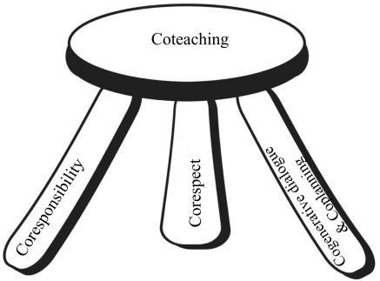

* Coresponsibility
* Corespect
* Coplanning
* Cogenerative dialogues

Scantlebury, Gallo-Fox, Wassell, 2008

Research has shown significant gains in student learning in cotaught classrooms when compared to student learning in traditional student teaching classrooms and experienced single teacher classrooms (Murphy & Beggs, 2006; St. Cloud University, 2010). One coteaching team in a Delaware school observed this increase in skills. ECE Clinical Educator Daphne Kosinski said, “I hosted a teacher candidate in the fall (2014). Our test scores went up more than the other classes in our team. I think that the coteaching, with two of us in the room helped improve skills” (Kindergarten). An Elementary teacher education clinical educator said, “Two perspectives are sometimes more helpful, especially for Middle school math. Students might relate more to one than the other, and it helps to have two different ways to teach the information.”

**Why coteach?**

“Coteaching explicitly brings two or more teachers together to improve what they can offer to the children they teach, while providing opportunities to learn more about their own teaching.”

**Why does coteaching work?**

**“**Coteaching works because everyone focuses on the learning of the children**.” “**Student and classroom teachers learn from each other (as well as Universitytutors), often without even realizing that this is happening**.”**

***(Source:*** Coteaching–Investigative Primary Science with Student Teachers[**http://www.pstt.org.uk/ext/cpd/coteaching/1.html**](http://www.pstt.org.uk/ext/cpd/coteaching/1.html) **)**

**Potential Benefits for Coteaching Participants**

**Potential benefits for classroom students**

* Another teacher in the room to monitor, assist and reach more students
* Coteachers can differentiate instruction to meet student learning needs
* Site-based clinical educators remain actively engaged to maintain stability and awareness of student academic and emotional needs
* More student small group time
* More individualized and specialized attention
* Transition of teacher candidate is smoother for the students, as there is visible support from the clinical educator

**Potential benefits for teacher candidates**

* Active role expectation – active engagement at all times
* Increased agency – greater sense of commitment to school, classroom and students
* Increased sense of confidence from working alongside an experienced teacher
* Increased ability to make decisions and coteachers gain experience engaging in shared decision-making processes
* More teaching time and engagement with students

**Potential benefits for site-based clinical educator**

* Opportunity to continue to instruct students and address learning needs
* Site-based clinical educator feels that they are no longer a spectator in their own classroom
* Professional development opportunity – the teacher candidate brings new perspective, fresh ideas, renewed enthusiasm and energy to the classroom
* Gain of a teaching partner to talk through ideas, try new instructional strategies, monitor students and collaborate on new lessons

**Research based long-term coteaching benefits**

* Six months after experiencing cotaught science, elementary students reported significantly more positive attitudes toward learning science than students who had not been cotaught science
* Site-based clinical educators utilize professional learning from coteaching experiences even after the teacher candidates leave their classroom.
* Fosters collaborative and networking practices
* Supports a culture of communication and collaboration within coteaching schools
* Coteaching graduates actively seek out teacher networks and use collaborative practices to support their teaching at their new schools

**Essential Coteaching Elements: The 4 Co’s Defined**

**I. Coresponsibility**

**Coresponsibility/Collective Responsibility/Shared Responsibility**

In a coteaching classroom all coteachers need to assume shared responsibility for all aspects of classroom life. This means that responsibility for classroom instruction, students, prepping and planning, management, and assesement is collective. If a coteacher sees that something needs to be addressed in the classroom, they should work to address these needs.

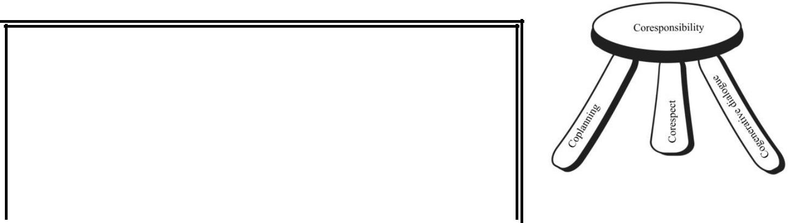

***Research Says…*** “Coteachers who see that something in thesituation that could or should be improved immediately go about making the required changes. Rather than sitting back and after the lesson talking about it or, worse, blaming the other for making mistakes, coteachers who enact their part of the collective responsibility [co-responsibility] do what can be done to improve the situation then and there” (Roth & Tobin. 2005, p. 19).

Scantlebury, Gallo-Fox, Wassell, 2008)

**UD site-based clinical educator thoughts *on Coresponsibility***

*“We both have different roles based on the lesson, so you’re responsible for your role and I’m responsible for my role. We’re both responsible for the learning of the students in the classroom. It’s like a team in a way.”* (Grade 4 Clinical Educator)

*“It’s not ‘figure it out’... it is a joint effort to execute lessons the best way you know how and to reach all the kids.”* (Grade 3 Clinical Educator)

*“These are* ***our*** *children.* ***WE*** *are responsible for all planning, teaching, learning and assessing.”* (Grade 3 Cooperating Coteacher)

**UD teacher candidates’ thoughts on Coresponsibility**

*“Coteaching was such a great experience for me as a student teacher. I immediately felt part of the classroom/grade level "team" and like what I had to say was important. Sometimes it didn't even feel like I was a student teacher because I was given so much responsibility!” (Early Childhood Teacher candidate)*

*Coresponsiblity means, “Taking ownership of everything even if you are in the supporting role. Making sure that you are both on the same page, making sure you are working together, making sure that you are both working together and planning together.”* (Grade 3 Teacher candidate)

*“This means that the responsibility to perform a task is shared between two or more people. It means that people share accountability, and thus everyone should be actively engaged in the task…” Coresponsibility defines my student teaching experience. My clinical educator and I were*

*coresponsible for planning, implementing, and reflecting on instruction.”* (Grade 1 Teachercandidate*)*

**II. Corespect**

All coteachers bring different strengths and important knowledge to classroom practice and can work to enhance student learning in the classroom. Research has found that through the process of teaching alongside one another and through shared conversation about practice all coteachers can gain new insights into practice, develop new ideas for instruction, and reflect on their work with students. It takes time to learn about one another’s strengths and the value that each person brings to the classroom this is why it is critical that coteachers work

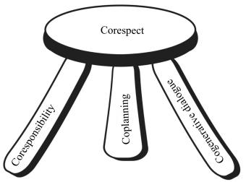

together to establish corespect during the early days and throughout the field experience.

It is important from the first day that teacher candidates contribute to classroom instruction and interact with students. Traditional student teaching models are often hierarchical with site-based clinical educator being viewed as experts, and teacher candidates viewed as novices. In coteaching both teachers are

seen as important contributors to the teaching process and are viewed by students equally in their teaching roles. Power differentials can make it difficult for classroom students to understand that they can, and should address their questions and concerns toward both teachers.

***Research Says…*** “Corespect occurred when teachers viewed each other as peers and hadthe expectation that each person provided valuable insight and knowledge that improved her/his teaching. For successful coteaching, all teachers, regardless of experience or expertise, had to respect each other’s talents and value the contributions that each individual could make to the classroom. Mutual co-respect provided room to maneuver within coteaching, and share voices, ideas and control” (Scantlebury, Gallo-Fox, & Wassell, 2007, p. 975).

**Site-based clinical educator’ Thoughts *on Corespect***

*“We were in it together and I think…we were both treated as individuals. We worked together but we respected each other, so they blended.”* (Grade 4 Clinical educator)

Teacher candidates *“bring a lot of new things to the classroom, not just their energy but their ideas,* *technology…it helps me to become a better teacher.”* (Grade 2 Clinical Educator)

**Teacher candidates’ Thoughts on Corespect**

*“We need to work well together, even if we don’t have the same ideas about something. We need to work on that before we go teach, because we can’t have conflicting ideas. We are both equals in the classroom. I know what really helped was that I was introduced as the other teacher in the class. I was never the “student teacher”…right off the bat, it was we are both teachers.”* (Grade 3 teacher candidate)

Scantlebury, Gallo-Fox, Wassell, 2008)

*“This means two or more people respect each other. Respect is not a one-way street and just like coresponsibility, corespect is another word that defined my teaching placement. My coteachers and I all respected each other, we listened to each other’s ideas, and we all worked with each other to provide quality instruction to these students.”* (Grade 1 Teacher candidate)

**III. Coplanning**

When coplanning, coteachers work together in pairs or teams to reflect on the current status of the class and collaboratively plan instruction. While

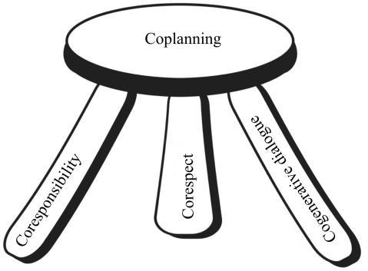

working together coteachers plan for instruction and assessment, and gain opportunities to think together about how to best meet student needs in the classroom. It is important that the teacher candidate is contributing member of the planning community.

During coteaching experiences the teacher candidate

should participate in the existing planning process at

the school. For example, if clinical educators plan with

colleagues the teacher candidate should participate in this process as fully as possible; coteachers may find that in such situations additional coplanning conversations based specifically on classroom student needs will be necessary to clarify and plan for specific

classroom implementation.

In order for coteaching to be successful coteachers structure a weekly time for big picture planning, reflection and goal setting. They then confer daily to adjust the implementation of the plan according to student needs.

Strong coplanning sessions incorporate the following elements:

* Shared common purpose for coplanning meeting
  1. (e.g. instructional planning for a lesson, week, or unit)
* Focus on student learning goals
  1. What do we want our students to learn?
     + Standards/ Curricular goals
  2. How will we know if our goals have been achieved?
* Planning with a focus on student needs
* Develop activities or practices to support successful learning
  1. How can we work together to best support our students?
  2. What type of coteaching approaches will best support our students’ learning?
* Cohesive coteacher relationship: Sense of safety and trust between coteaching partners (corespect & coresponsibility)

During the coplanning session it is important to communicate all expectations for the week in terms of roles and responsibilities. Plans are made to utilize both coteachers’ strengths to best meet the students’ needs. After the coplanning sessions, the coteachers then accept the responsibility of preparing for their roles and responsibilities.

Experienced teachers automatically consider many factors when planning that a teacher candidate needs to learn when developing appropriate plans for instruction. During early coplanning sessions coteachers often talk about aspects of planning that experienced teachers think about implicitly. Much of the experienced teacher’s tacit knowledge needs to be made explicit. Some topics addressed in early coplanning meetings include:

* *How will we arrange the classroom for the lesson? How/why will we group and situate children in the room in certain ways? How do we prepare the students to work together, or use the materials for in our lesson?*
* *What materials do we need to prepare or differentiate for the lesson? When do we set up for the lesson?*
* *How will we pace the lesson?*
* *How is the content aligned with Common Core Standards and/or State Standards?*
* *How will student assessment data, prior knowledge and experiences inform current and future instruction?*
* *Will accommodations or modifications need to be considered for special needs students? (For example: ELL, 504 Accommodations, and IEPs)*
* *What differentiated strategies need to occur to meet the varied tiered learners?*
* *How can the “power of two coteachers” or “power of three coteachers” be used to best meet students’ needs?*
* *What instructional approaches can be used to best meet the learning needs of classroom students?*
* *How will formative and summative assessment(s) measure each student’s progress towards the lesson’s essential question/objective(s)/standards?*

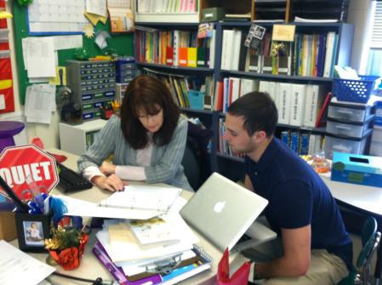

**Thoughts about coplanning:**

An elementary clinical educator, Richele Pryor, remarked that, “*Coteaching was less* *scary (for the teacher candidate) because she could look at me for help. It gave her more confidence.*” (March 2015)

**IV. Cogenerative Dialogues**: Shared mutual reflection on practice

**(Communication)**

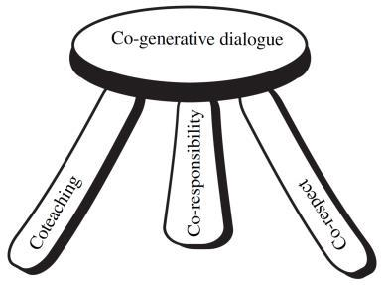A natural process in our development as professionals is reflection upon instruction. The coteaching model provides opportunities for the clinical educator and teacher candidate to reflect together to discuss lesson strengths, weaknesses, and strategies for future improvement. Your coplanning sessions are a form of cogenerative dialogue! Throughout the day, discuss these issues. Thinking aloud improves the education for all learners!

Scantlebury, Gallo-Fox, Wassell, 2008)

***Research Says…***

Cogenerative dialogues occur when coteachers discuss the issues that impact teaching and learning, and collectively generate solutions to any problems. Cogenerative dialogues are open discussions in which all participants’ opinions and voices have equal value.” (Scantlebury, Gallo-Fox, & Wassell, 2008, pp. 971-972).

**Example in Action**: Did you know that cogenerative dialogues might occur during a lesson?

Research in coteaching calls this a “huddle.” Here is an example: *Ms. P. (CE) is teaching a math* *lesson to her second graders. The students are exploring two-digit addition. Ms. S (TC) is supporting instruction by monitoring the students and attending to individual needs. Both Ms. S. and Ms. P. realize that several students are really struggling with the new concept. As the students continue to discuss strategies in their small groups, Ms. S. and Ms. P. meet in the corner of the room to discuss their observations of student progress/learning. After a few minutes, they decide to make a lesson adjustment. Ms. P. decides to take a small group of students to the back table while Ms. S. continues the lesson with the remaining second graders.* (Grade 2 Classroom,Fall 2011)

***Research Says…***

“The chief goal of a huddle is to quickly reach agreement on what is to be done, the roles of the participants, and shared responsibilities for enacting agreed to roles successfully. During huddles the coteachers participate in *ad hoc* cogenerative dialogues and it is important for each to listen to others and ensure that all points of view are presented, heard, and taken into account in reaching a final agreed-to course of action” (Tobin, 2006, p 139).

**UD site-based clinical educator’ thoughts *on Cogenerative Dialogues***

*“I think it’s probably the most valuable part…especially because I was involved… If I were the teacher that was sitting back while they were teaching, I probably would have been grading or something, but because I was involved in the lessons, I knew everything that was happening. So it’s easy to reflect when you’re both involved.” (*Grade 4 Clinical Educator )

“*We are always talking about what’s going on, what’s working what’s not working, what we need to* *change. We definitely tried to look at all of the assessments together. We would always talk about where do we need to improve, where are we noticing the trends and what needs to be done again. If we were in agreement with what those things were, it was clear to see what needed to be taught again, then figure out how to work it back in.”* (Grade 4 Clinical Educator)

**UD Teacher candidates’ Thoughts on Cogenerative Dialogues**

*“I think we reflected together equally. She would ask me ‘What do you think?’ She would say, as a pre-service teacher with all these fresh ideas from Delaware… ‘What do you think I could have done?’ ”* (Grade 3 Teacher candidate)

*“It was like mutual reflection…we could bounce ideas off of each other.”* (Grade 3 Teacher candidate)

*“We would discuss how we thought the lesson went. We would talk about things that went well and things that could be improved upon. We would also reflect on the lesson in terms of future instruction-we would decide how to guide instruction in the future based on how the lesson went and based on which students met the lesson’s objectives and which did not. When reflecting it was more of a conversation with my coteacher than a one-sided discussion; as with planning, my thoughts were fully valued and I did not feel hesitant or nervous to share my opinions.” (Grade 1 & 2 Teacher candidate).*

**University based clinical educator thoughts on cogenerative dialogue**

*Ann Jornlin said, "With coteaching, reflection is occurring in the moment as opposed to after the lesson." (March 17, 2015)*

*Another University based clinical educator, Dede Lilly said, “As a part of this program as an undergrad and now as a supervisor, I feel like this is a key part that was missing. Coteaching really helps teachers support each other.” (March 17, 2015)*

**Supporting Student Learning through Coteaching**

**Pedagogical Approaches for Enhancing Instruction**

Coteaching is the shared responsibility of classroom practice with a joint focus on student learning. With multiple teachers in the classroom there are many ways to work together to support student learning. Coteachers should consider pedagogical approaches that will help them fully utilize the human resources in the classroom in order to meet their instructional goals. Successful coteachers plan with student needs in mind. They develop their instructional plans in ways that best enable them to meet the goals and needs of the children in the classroom. While planning is necessary for effective instruction, many teachers find that they need to adapt their teaching in the midst of instruction in order to better support student learning.

It is valuable for teacher candidates to use a variety of coteaching approaches, as each provides different opportunities for learning and thinking about student learning. Some approaches provide opportunities for both coteachers to truly merge their practice by coteaching the exact same lesson together and reflecting on their shared practice. Other coteaching approaches provide greater opportunity for teacher candidates to assume lead instructional roles in the classroom, while still having the proximity of the clinical educator for support and reflection.

Coteaching can take many forms. Some approaches for coteaching are listed on the following pages:

**Key:**

**D** = A coteaching approach that strongly supports differentiated instruction for students.

**I** = A coteaching approach that provides independent teaching opportunities for the teacher candidate. **TC** = Teacher candidate

**CE**= Site-based Clinical educator

**SE** = Special educator

**Unified Coteaching**

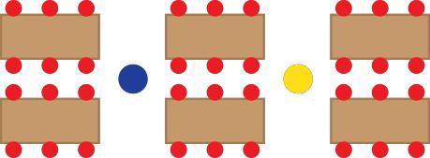

A goal of coteaching is for both teachers to truly share classroom and instructional responsibilities. When unified coteaching is fully attained, teacher practice is mutual and coteachers are able to anticipate each other’s moves. In unified coteaching both coteachers have equal roles in the lesson. The process of “stepping forward and stepping back" as the lead teacher and/or assist teacher is often planned. While coteachers continually work together to share and discuss practice throughout their time in the classroom; strongly synchronized coteaching as described here takes time to develop.

**Example in Action 1**:*Ms. N. (TC) is coteaching with Ms. E. (CE) and Ms. G. (SE) in a first-grade**inclusion classroom. They have coplanned a science lesson on the types of clouds. As the lesson progresses, Ms. N. is introducing the lesson, Ms. E. shares a connection to a recent reading story, Ms. G. signals that she also has a connection to a movie she recently saw on T.V. The lesson progresses with all three coteachers having equal roles in the lesson and seamlessly stepping into the lead role and fading back out as another coteacher steps forward. An observer would think that this partnership has been teaching for years together.* (Grade 1 classroom, Fall 2011)

**Example in Action 2***: Ms. C. (TC) and Ms. J. (CE) are introducing the visiting class pet to the**children. Both teachers shared information about the hermit crabs with the children. Ms. J. shared about personal experiences with the hermit crabs, as they are her daughter’s pets at home. Ms. C. shared information that she learned through reading about hermit crabs online. Students listened to each example and asked questions of their own.* (Preschool classroom, Spring 2014)

**Teach and Actively Observe Students** I

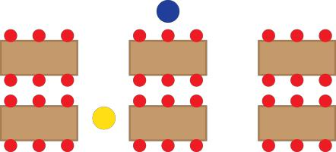

In this coteaching approach one teacher leads class instruction while the other actively observes the classroom. This is a time for anecdotal note taking, child study, or curriculum assessment. The coteacher observing is engaged in the classroom activity and ready to support instruction as needed. This approach can be for both parties of the coteaching team from time to time.

**Example in Action 1:** *During a Preschool group time, Mrs. D. (CE) is reading a book to the**children. Ms. K. (TC) is sitting with the children, listening and taking notes about student responses to the questions and the text. This process continues over a week of daily read alouds, so that assessment can occur for many children. Ms. K. notes who has been called on to answer a question and each child’s response. This information is used by both coteachers so that they can ensure all children have opportunities to respond to a reading during the week, and also as a way to document each child’s response to oral reading comprehension questions. (Fall 2013)*

**Example in Action 2***: In a second-grade classroom, Ms. P. (TC) is leading the math portion of the**day. The children are using materials with a partner to solve word problems. While Ms. P is teaching the whole group, Ms. F. (CE) is observing and taking notes on student understanding. She will then use this data to form small groups for further understanding, or enrichment. (Spring 2014)*

**Teach and Assist** I

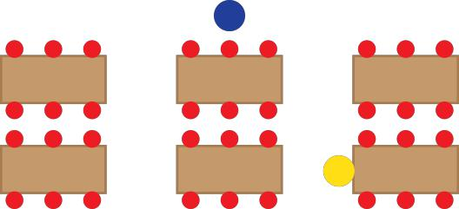

One coteacher takes a lead in providing instruction, while the other monitors the classroom for management and student understanding, and assists individual students. As one coteacher begins to take on lead roles, the other coteacher remains actively engaged in the lesson and provides ongoing support. Clinical educator and teacher candidates can fill both roles during a lesson or even trade mid-lesson. The assist role provides a great opportunity to coach the teacher candidate, model decision-making skills, or model instructional strategies. The assist role also provides coteachers with opportunities to work more closely with students, monitor progress, observe behaviors, and remain engaged in the classroom. Even with “Teach and Assist” the lessons need to be coplanned to identify clear roles and flow of the lesson.

**Example in Action 1***: During week one of the teaching experience, Mr. K. (CT) is taking the lead**role for Problem of the Day. Mr. K. is listening intently to students’ strategies for solving the problem, he is unfamiliar with some connections to previous learning. From the coplanning session, Mr. K. knows that his clinical educator will be actively supporting instruction and may model connections. From the coplanning session, Ms. O. (CE) is prepared to help make connections to previous learning if a strategy is shared that was not discussed during the coplanning session. This coteaching strategy provides the students with appropriate instruction as Mr. K learns the curriculum and previously learned concepts.* (Grade 8 classroom, Spring2012)

**Example in Action 2***: During movement time, the teachers are focusing on gross motor**development. Mrs. T (CE) is leading the activity; Ms. K. (TC) is assisting. Children are listening to the music to cue them to the next movement. Both coteachers are participating with the movements, modeling expected behaviors for the children. Mrs. T. is leading the activity and signaling to students to listen for the next section of movement, while Ms. K. gives smiles of encouragement and moves in to provide redirection and one-on-one modeling for specific children as needed. Both coteachers are in different location in the room to support all children, by proximity.* (Preschool classroom, Fall 2013)

**Center/Station Teaching** ID

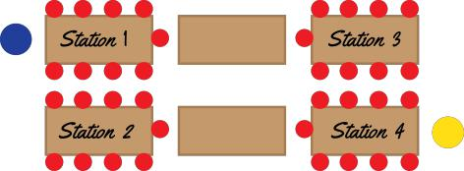

During instruction both coteachers may be working with different groups of students around different or similar goals. Coteachers divide the instructional content into two or more smaller components and present this content at separate locations/centers in the room. Student groups transition from coteacher to coteacher; sometimes a third or fourth center of independent work may be incorporated. Center/Station Teaching allows for independent teaching opportunities for the teacher candidate. This is an excellent approach for differentiating instruction.

**Example in Action 1**:*Ms. J. (CE) and Ms. B. (TC) have coplanned a reading unit. There are four**student centers arranged in the classroom. Two of the centers provide students with independent tasks while Ms. J. and Ms. B. instruct the remaining two centers. The students transition to a new center every 20 minutes. Ms. J. is working on student comprehension through leveled readers. Ms. B is working with students on the weekly skill of cause and effect.* (Grade 4 classroom, Spring2011).

**Example in Action 2***: In many Early Childhood Classrooms center time occurs each day. Often**the room is set up with hands on learning stations that the children rotate through. One coteacher may be at a small group providing focused instruction and support, while another coteacher is monitoring classroom activity, and interacting with groups throughout the room.* (Common early childhood classroom practices)

**Example in Action 3:** *At the onset of a unit about the properties of waves coteachers**developed a two-day mini-lab in which high school science students participate in a series of constructivist learning opportunities and explored concepts of wavelength, frequency, and amplitude. Each laboratory station was set up with different hands-on activities that students circulated to throughout the course of the two days. One coteacher led a pendulum activity at one station, the other coteachers facilitated learning at the other*

*stations. The coteachers then used these constructivists learning opportunities as foundational experiences for their physical science study.* (High school science classroom,Spring 2005)

**Split-class Instruction: Parallel Teaching**I

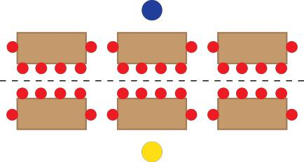

There are multiple reasons why coteachers might choose to split the class. During split-class instruction each coteacher may teach the same lesson using the same approaches, or through different approaches but with the same goals. Split-class instruction provides one way to decrease student to teacher ratios and groupings may be heterogeneous or homogeneous depending upon instructional goals. Split-class instruction allows for independent teaching opportunities for the teacher candidate.

**Example in Action 1***: Ms. G. (CE) and Ms. S. (CT) have coplanned a math lesson on adding**fractions. To differentiate the instruction, Ms. S. is going to stay in the classroom and instruct 8 students who need time to explore the concept of adding fractions. Ms. G. is going to work in another area outside of the classroom with 15 students who already have an advanced understanding of adding fraction.* (Grade 5 classroom, Fall 2010)

**Example in Action 2***: Ms. M. (CE) and Ms. T. (CT) have coplanned a writing lesson. They**introduced the lesson in a short whole group meeting then split the class into two groups. Each group will write about their field trip experiences in their journals. The lower ratio will allow the coteachers to meet student’s needs faster, with more appropriate, individualized support.* (Kindergarten, Fall 2012)

**Approaches for Individualizing Instruction for Students**

**Split-class Differentiation** ID

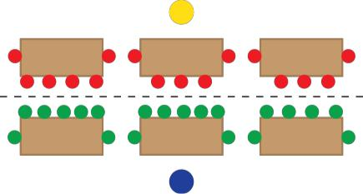

This approach is similar to parallel/split class teaching as a class is divided into two groups. Differentiated instruction is planned to meet the unique needs of the students within the two groups. The learning goals are the same, but the instruction is differentiated.

**Example in Action 1:** *Ms. J. (CE) and Ms. B. (TC) coplan to differentiate a math lesson on**multiplying fractions. Based on pupil learning data and observations, Ms. J. instructs almost half of the pupils using fraction strips to reinforce the concept. Ms. B. takes the remaining pupils in the class – a little more than half, to instruct the same concept but focuses the lesson on understanding and applying the algorithm.* (Grade 4, Spring 2010)

**Example in Action 2:** *Ms. K. (TC) and Ms. T. (CE) and Ms. L. (Paraprofessional) will each teach a**reading readiness lesson to their small groups. Ms. K.’s group is ready for blending sounds to make words. Ms. T.’s group is working on matching letters to their sounds by sorting different objects to their corresponding printed letter. Ms. L.’s group is playing a matching game by putting together magnetic letter pairs. Each group is working on skills appropriate to their needs as determined by prior assessment and observation.* (Preschool, Fall 2013)

**Supplemental Teaching** ID

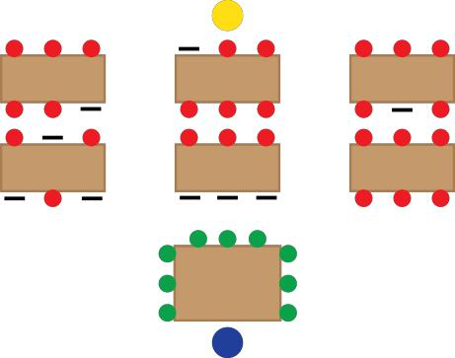

While one teacher is leading classroom instruction, the other coteacher works independently with one student or with a small group to help strengthen student learning. Some of types of

instruction accomplished while using this approach include: RTI, tutoring, supplemental instruction, catch up for students who have missed class, or enrichment. *This is a planned* *teaching experience*; coteachers coplan ahead of time to have one coteacher working with asmall group during the whole group instruction.

**Example in Action:** *Mrs. B. (CE) and Mr. C. (TC) coplanned a lesson on word families. A majority**of the children would be in a group with Mr. C. to learn about the newest word family,” –up”. They will explore ways to create new words by changing the initial sound. Mrs. B. will work with a small group of children to provide extra support practicing letter sounds in isolation then they will use these same sounds create new words. (Kindergarten, Spring 2013)*

**Teach & Regroup** ID

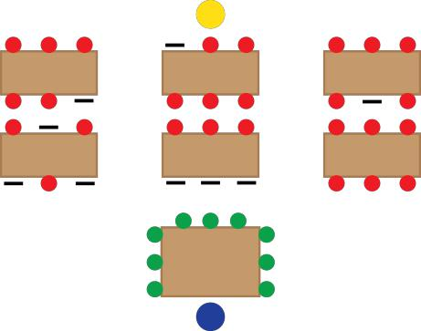

*During instruction*, coteachers identify students who may be struggling with the concept beingtaught. This is done during the lesson. Coteachers discuss the needs and decide on flexible groups that need additional support. The non-lead coteacher regroups a smaller group of students from the whole group to provide more individualized small group instruction.

**Example in Action 1:** *Ms. T. (TC) is teaching math to an inclusion group of fourth grade**students. During the course of the math instruction the clinical educator and the special education (SE) coteacher are monitoring the students’ understanding through observations as they walk through the classroom. Mrs. B. (TC) notices four students who are missing a key concept in adding fractions and are falling quickly behind the pace of the lesson. Mrs. B. pulls the four students to a small table at the side of the classroom to individualize their instruction. Ms. T. (TC) and Mrs. V. (SE) continue in their roles for the coplanned lesson.* (Grade 4 classroom, Fall2012)

**Example in Action 2:** *In a Second Grade classroom, Mrs. W. (CE) leads the math lesson.**The instruction for the concept is brief. Ms. J (TC) is monitoring the room and determining who needs additional support on this skill. Mrs. W. divides the room into three groups; she gets the independent group started on their work. Ms. J. works with a group that needs to work with manipulatives to support conceptual understanding. Mrs. W. works with a*

*group of children that are above-grade level group to explore the concept in more detail.* (Grade 2 classroom, Spring 2013)

**Becoming a Coteacher:**

**Tips for the Teacher Candidate**

Teacher candidates are encouraged to take an active role in the classroom from the first day in the semester. One way to accomplish this is by not sitting down! Teacher candidates should be actively working to become a part of the classroom life even from the first day. We realize that it is not realistic to think that teachers new to a classroom can fully participate in all aspects of classroom practice on the first day—this happens over time. Below is a list of coteaching activities that are reasonable expectations during the initial weeks of coteaching to help the teacher candidate integrate fully into classroom life. This is a suggested progression of activities. Do what makes sense to you and your classroom; you do not need to do everything at once.

***Research Says…*** “The coteaching model offers interns a method for explicitly drawing onopportunities to learn a practice by doing it collectively with others and cogenerative dialogues provide interns a means to reflect on this process with others in an effort to improve teaching and learning and also, to learn about teaching.” (Martin, 2008)

|  |  |  |
| --- | --- | --- |
|  | **Possible coteaching activities and practices** | |
| **Prior to the** | • | Contact your site-based clinical educator to introduce yourself |
| **placement** | • | Try to visit the school or classroom to meet the students |
|  | • Look up and read the clinical educator’s website and the school’s | |
|  |  | website |
|  | • Determine at least two routes to school | |
|  | • | Exchange contact information |
|  | • Ask about your new schedule | |
| **Week 1:** | • | Interact with all the children in your classroom. Get to know them as |
| ***Becoming part of*** |  | individuals and learners |
| ***the life of the*** | • | Get to know your clinical educator; begin to develop a working |
| ***classroom*** |  | relationship |
|  | • Get to know all of your students; learn everyone’s names | |
|  | • Actively work to insert yourself into the activity of the classroom (sit | |
|  |  | down less than your clinical educator); provide instructional support |
|  |  | and assistance |
|  | • Read a story with a child, or a small group of children | |
|  | • Check for student understanding (listen in to student comments during | |
|  |  | instruction, answer questions as appropriate and work to support |
|  |  | student learning, ask for clarity and help to bring questions to the floor) |
|  | • | Answer student questions |
|  | • Work one-on-one with a child or in small groups | |
|  | • Try *Center/ Station* or different coteaching approach* | |

|  |  |
| --- | --- |
|  | • Tutor a child, provide extra support as needed |
|  | • Begin to learn and support classroom management |
|  | • See where there are needs and step in to support learning |
|  | • Actively observe students -- document learning, record anecdotal notes |
|  | • Attend staff and faculty meetings |
|  | • Coplan with your clinical educator (and team) |
|  | • Read curriculum and instructional materials; gain an overview of |
|  | instructional goals for the semester |
|  | • Learn and follow school policies and procedures for teachers |
|  | • Set professional goals for week 2 |
|  | • Begin *Coteaching Conversations\*\** |
| **Week 2:** | • Continue the coteaching practices from last week and add to them |
| ***Assuming a*** | • Continue to coplan with your clinical educator (and team) |
| ***greater share of*** | • Run a center or small group activity |
| ***classroom*** | • Try *Split-Instruction* or *Supplemental* coteaching approaches** |
| ***responsibility*** | • Set professional goals for the week |
|  | • By the end of week 2 you should be coteaching throughout the day |
|  | • Complete *Coteaching Conversations* by end of week 2 |
| **Week 3 through** | • Continue the coteaching practices from previous weeks and add to |
| **last week of** | them |
| **placement:** | • Continue to keep student learning needs as a central focus of your work |
| ***Mutually shared*** | • Continue to move toward equal partnership in the classroom |
| ***practice*** | • Continue to set professional goals each week |
|  | • Continue to reflect together about student progress and the types of |
|  | assessment you might use to help guide your planning and lessons. |
|  | • Remember, coplanning should be a mutual experience. Continue to |
|  | actively engage all coteachers in planning of all aspects of classroom |
|  | practice. |
|  | • Learn more about the school/center and the roles within the building. |
|  | • Spend some time talking with support personnel to learn more about |
|  | how to better support the students |

* See *Supporting Student Learning through Coteaching* (pp. 12-18) or *The Coteaching Strategies Quick* *Guide* (p. 31) for descriptions of the coteaching approaches.
* See *Coteaching Conversations* (pp. 22-23).

**Becoming a Coteacher: Tips for the site-based clinical educator**1

**Prior to the placement**

* Talk with your teacher candidate — spend time sharing about yourselves. If possible, invite your teacher candidate to visit before the official start of the experience.
* Share excitement with students and families about the start of the placement. Welcome the teacher candidate in a newsletter or email.
* Include the teacher candidate’s name next to yours outside the door, or on a family bulletin board.
* Provide a work area for the teacher candidate. Designate a shared area with standards, curriculum manuals, textbooks, the current read-aloud book, etc.
* Share a picture of the class and/or individual students to help the teacher candidate ‘know’ them even before the placement. Have the class write a welcome letter to the teacher candidate.
* Create a folder with useful information including class lists, daily schedules, allergies, classroom rules, discipline referral forms, etc.
* If applicable, make arrangements for student teacher’s login and access to e-School, or electronic attendance & grade book.
* Make arrangements for parking.

**Day 1**

* Introduce the teacher candidate to other staff, including the administrative staff and custodians.
* Tour the school. Be sure to share staff work areas, resource room, the cafeteria, the lounge, adult restrooms, etc.
* Share with the teacher candidate school policies for teachers: the work day hours, log in and call out procedures, school security and drills, how and when to contact nurse, parking, parent volunteers, etc.

**During the first week**

* Share information about how and when you work/communicate with other staff.
* Share how you assess student progress, and the system you use, if applicable.
* Share information about students’ medical, behavioral and emotional needs. Invite the teacher candidate to look at IEP and 504 goals, and share how the goals are addresses and assessed.
* Review the calendar and discuss any details about professional days, staff or student events. Discuss routines in your workday such as recess, lunch duty, faculty meetings, team planning, bus duty, etc.
* Discuss any behavior management system in place, expectations for behavior and classroom routines. Discuss the school wide behavior plan.
* Look for ways to be kind, positive and supportive of the teacher candidate and the contributions they are making to the classroom environment

1. Handout adapted from St. Cloud to reflect UD coteaching philosophy

**Getting Started: Coteaching Conversations**

Coteaching requires collaboration and time to get to know each other on a professional level. During the first two weeks of the field experience it is important to have professional and collaborative conversations around important coteaching topics.

Please arrange time to review and discuss the following ideas and questions.

**Possible Corespect Discussion Questions**

1. How do we each define professional respect for each other?
2. How will we respect each other’s:
   1. work space
   2. materials
   3. ideas
   4. teaching style
   5. feedback
   6. experience
3. How will we ensure regular communication with each other?
4. Additional ideas discussed about corespect
5. Questions we still have about corespect.

**Possible Coresponsibility Discussion Questions**

1. How will we define our roles for each lesson?
2. How will we determine each coteachers’ individual responsibilities for lessons and ongoing student learning?
3. How will we demonstrate equal responsibility for classroom responsibilities?
4. Focusing on the domains of teaching, share with each other the knowledge and strengths that you each bring to the following classroom practices:
   1. planning instruction
   2. assessment
   3. management
   4. reflection
5. How will we explain our coteaching arrangement to the students and convey that we are equals in the classroom?
6. How will we be consistent in dealing with student behaviors?
7. How will we assess the effectiveness of our instruction?
8. Additional ideas discussed about coresponsibility
9. Questions we still have about coresponsibility

**Establishing Shared Goals for Student Learning**

As part of the formation of your coteaching partnership, you need to develop a shared sense of focus on student learning. As a collaborative team, you need mutual goals for student learning and instruction. Take time to discuss student learning needs and curricular goals for the upcoming placement. While many of these goals are set at the state and district level, a common vision and sense of purpose will help you to coplan and coteach. Here is a list of points to discuss together:

1. What are the curricular/instructional goals for the placement weeks?
2. Which standards will need to be addressed? How have you worked with standards in the past?
3. Which curricular resources and teacher guides are typically used in this classroom? (The teacher candidates should gain access to these materials and take time to familiarize themselves with these materials.)
4. Which students have an IEP or 504, and what are their goals? How are these goals addressed in the classroom? How is this data tracked?
5. How is student learning document in your classroom? Where and how is this data recorded and reported?

**Communicating/Reflecting Together (Cogenerative Dialogues)** Coteachers reflect on their practice throughout the day. They discuss their teaching and student progress in huddles, coplanning sessions, and when they debrief a lesson. Reflection occurs right after the lesson, in a brief conversation and/or in formally scheduled debriefing sessions.

**Possible Cogenerative Dialogue Discussion Questions**

1. **Huddles:** What signal might we use to get each other’s attention during a coteaching lesson toindicate that we need to huddle up to quickly touch base about instruction?
2. **Coplanning**: Successful coplanning is a type of cogenerative dialogue. Together coteachersreflect on previous instruction, and plan to move student learning forward. This is a mutual process where all coteachers share the responsibility for developing instruction.

Discuss how everyone can be equal contributors in a coplanning session. Discuss how you might pre-plan and prepare for coplanning sessions so that your coplanning time can be used most efficiently. Discuss potential resources that you might draw on prior to coplanning that can inform your thinking during coplanning meetings.

1. **Cogenerative dialogues about practice:** If classroom practice is not going in a way that Iagree with, what is the best way to bring this issue up?
2. **Cogenerative dialogues about practice:** Reflect on the things that you are already doingwell as a team, and set goals for your shared practice for the upcoming week.
3. **Debriefing Instruction:** Reflect on one lesson from the day and discuss the impact on studentlearning. What did students learn during the lesson? What evidence do you have to support your points? How will you build on this instruction to further strengthen student understanding? How will you meet these goals as a coteaching team?
4. Is there anything else that our partnership needs to discuss or clarify?

**\*The conversations throughout this section are all forms of cogenerative dialoguing.** We encourage you tocontinue and revisit these conversations as you coplan for student learning and experience the day to day issues in the classroom! Communication is key to a successful coteaching experience!

**References**

***The Coteaching Resource Guide is informed by the following publications***

Bacharach, N., Heck, T. W., & Dahlberg, K. (2010). Changing the face of student teaching through coteaching. *Action in Teacher Education, 32*(1), 3-14.

Carlise, K. (2010) Enactment of coteaching in primary schools: Moving towards a shared responsibility.

In Murphy, C. & Scantlebury, K. (Eds.). *Coteaching in international contexts: research and practice, cultural* *studies in science education* (125-146). Springer Science +Business Media B.V.

Coteaching – Investigative Primary Science with Student Teachers

<http://www.pstt.org.uk/ext/cpd/coteaching/1.html>

Gallo-Fox, J. & Scantlebury, K. (2015). ”It isn’t necessarily sunshine and daisies every time:” Coplanning opportunities and challenges when student teaching”. *Asia-Pacific Journal of Teacher Education*.

Martin, S. (2008). What is Necessary May not be Sufficient: An Analysis of Collaborative Models for

Learning to Teach Science. In Roth, W.-M. & Tobin, K. (Eds.). *World of science education*: North America.

Sense Publishers.

Murphy, C. (n.d.) Investigative primary science with student teachers. Retrieved from <http://www.azteachscience.co.uk/ext/cpd/coteaching/5_1.html>

Murphy, C. & Scantlebury, K. (Editors). (2010). *Coteaching in international contexts: Research and*

*practice*. London: Springer Publishing.

Murphy, C., Scantlebury, K., & Milne, C. (2015). Coteaching in science teacher professional development:

1. Vygotskian framework. *Asia-Pacific Journal of Teacher Education*.

Roth, W.M., (1998). Science teaching as knowledgeability: A case study of knowing and learning during coteaching. *Science Education,* 82, 357-377.

Roth, W.M., & Tobin, K. (2002). *At the elbow of another: Learning to teach by coteaching*, Vol. 204. New

York, NY: Peter Lang.

Roth, W.M., & Tobin, K. (2005). Coteaching: from praxis to theory. *Teaching Together, Learning Together*.

New York: Peter Lang.

Scantlebury, K., Gallo-Fox, J., & Wassell, B. A. (2008). Coteaching as a model for pre-service science teacher education. *Teaching and Teacher Education, 24*(4), 967-981.

Scantlebury, K., Gleason, S. Gallo-Fox, J. & Rulon, M. (2004). Tag team wrestling, or whose line is it anyway? Coteaching in a secondary science education program. Paper presented as part of interactive symposium, Learning to teach science using coteaching and cogenerative dialogues. Association for Educators of Teachers of Science, Nashville, TN.

St. Cloud University. Co-Teaching as Best Practice in Student Teaching. Mentoring Teacher Candidates Through Coteaching: A train the trainer workshop. University of Delaware, June 2013.

Tobin, K. (2006). Learning to teach through coteaching and cogenerative dialogue. *Teaching Education***,** 17(2): 133-142.

Tobin, K. Scantlebury, K., Roth, M, Lavan, S-K, Martin, S. & Wassell, B. (2005). Learning to teach science using coteaching and cogenerative dialogues. AETS, Nashville, TN.

Wassell, B.A. (2005). Coteaching as a site for collaborative research. Roth, W.M., & Tobin, K. (Eds.).

*Teaching Together, Learning Together* New York, NY: Peter Lang. pp. 121-139.

**Coplanning Tips**2

Coplanning is a type of cogenerative dialogue, and must occur weekly in order to support successful coteaching. This is a time to reflect on previous instruction and its impact on student learning and plan for continued instruction. Coplanning is a mutual process; you need to arrive at coplanning meetings prepared to contribute ideas and assume shared responsibility for the ongoing development of instruction.

Before coplanning:

* Determine when your planning time will be and keep it as consistent as possible; Set a time to plan each week and stick with it
* Decide what your focus will be during your planning time
* Discuss how everyone can be equal contributors in a planning session
* Arrive having read the curricular materials and textbooks
* Bring resources and materials to share during your planning session
* Be ready to think about and share ideas for modifications, accommodations, enrichment and differentiation for general plans

During coplanning:

* Reflect on previous instruction (cogenerative dialogue)
* Discuss your current goals for student learning (What do you expect that the students currently understand and are able to do, and what you want them to learn in the next week?)
* Take time to communicate about current instructional questions or issues
* Think about your students and determine what teaching and coteaching strategies would best meet their needs, including any inclusion practices
* Discuss a variety of assessment strategies—determine which data will be collected and which coteacher is responsible for this; Set a time to review and discuss this data in order to inform ongoing instruction
* Discuss the shared responsibilities for lesson preparation; who will gather materials, make copies, prepare the classroom for instruction, clean up, prepare parent newsletters, etc.?
* Decide the roles of each coteacher

After coplanning:

* Write the lesson plans, using the format designated by your school and/or program
* Complete the responsibilities discussed, gather materials and organize the room for implementation

**Important points to Remember**

* Planning is VERY important; Coplanning must happen at least once a week.
* The goal is to have both the clinical educator and teacher candidate actively engaged with students
* EVERY teacher candidate DOES need time to step forward and manage the classroom, through all the daily routines and lessons
* The ‘lead’ week provides the perfect opportunity for the teacher candidate to oversee all aspects of the classroom, including delegating of responsibilities of other adults
* Remember that you are both coteaching and **always focusing on student learning**

1. Resource adapted from St. Cloud to reflect UD coteaching philosophy

**Coteaching Triad Roles**3

**Role of the site-based clinical educator**

* Be welcoming and inviting (see welcome tips for ideas)
* Encourage teacher candidate to get involved
* Share materials, curriculum, standards, resources, ideas
* Include the teacher candidate in team activities; planning, assessment meetings, school wide meetings
* Share planning grids or assessment data collection forms you use
* Be knowledgeable about the coteaching approaches and work to implement them
* Model effective teaching strategies and best practices
* Participate in all classroom instruction
* Be flexible; allow for new ideas and try new techniques
* Communicate through cogenerative discussion, informal reflection, and notes during observations

**Role of the teacher candidate**

* Come to the placement eager to learn and show initiative
* Be an active participant in all aspects of the day; help with routines, be ready to teach at a moment’s notice
* Share ideas and work cooperatively
* Respect the work space of your colleagues
* Be knowledgeable about the coteaching approaches and work to implement them in ways that support student learning
* Prepare for coplanning meetings; arrive having read curriculum materials and with ideas for instruction
* Be proactive with communication
* Make adjustments, based on feedback, and seek constructive criticism
* Be patient with all parts of the team; forgive yourself when things don’t go as planned—learn to reflect and adjust the plan

**Role of the University based clinical educator**

* Coordinate an initial, middle and final conference for the triad
* Be consistent with your visits and observe many different parts of the day
* Provide feedback for each visit and on emailed lesson plans
* Be available to listen and lend support to both coteachers.
* Help build good communication amongst the team
* Be knowledgeable about the coteaching approaches and make suggestions when appropriate
* Be knowledgeable about university guidelines, procedures, policies, and expectations
* Advocate for the teacher candidate
* Set clear expectations
* Participate in classroom instruction as much as appropriate

1. Handout adapted from St. Cloud to reflect UD coteaching philosophy

**Are We Coteachers?**4

1. **Do we share responsibility for determining:**
   * 1. what to teach?
     2. what teaching strategy(s) to use?
     3. how to assess student learning?
2. **In planning, do we:**
   * 1. have regularly scheduled times to meet and discuss our work?
     2. communicate our concerns freely?
     3. each contribute to the planning process?
   1. **While coteaching, do:**
      1. both teachers work with all students?
      2. we use a variety of coteaching roles?
      3. students see both teachers as equal partners in the classroom?
      4. we both participate in the assessment of the students?
      5. we make changes as needed during a lesson (huddles)?
      6. we actively reinforce classroom rules and manage the classroom together?
      7. we demonstrate corespect?
   2. **After the cotaught lesson, do we:**
      1. provide feedback to one another on what goes on in the classroom?
      2. make improvements in our lessons based on what happens in the classroom?
   3. **Coteaching characteristics, qualities, and functions:**
      1. depend on one another to follow through on tasks and responsibilities?
      2. have both coteachers participate in parent/family communication?
      3. model collaboration and teamwork for our students?
      4. have a process for dealing with any disagreements we have?
      5. provide mentoring to others who want to coteach?
      6. communicate with our administrator about our needs as a coteaching pair?
      7. reflect on pupil learning?
      8. reflect on pupil products/student work?

**Coteaching is and is not…**

**Comparing coteaching to other models of collaborative teaching or student teaching**

|  |  |  |
| --- | --- | --- |
| **Coteaching** | **Team Teaching or** | **Traditional Student** |
|  | **Special Education** | **Teaching** |
|  | **Inclusion (Coteaching)** |  |
| All teachers are equals | All teachers may be equal, | Classroom observation |
| who bring different | but it may depend on | followed by classroom |
| expertise to the classroom | content knowledge | take-over |
| Shared classroom | Often special education | Trial by fire – is quickly in |
| responsibility | teacher focuses only on | charge of all students with |
|  | special education students | little or no support |
| Focus on student learning | Focus on student learning, | Should be focused on |
|  | may be upon very specific | student learning, but may |
|  | students | be distracted by focusing |
|  |  | on own development as a |
|  |  | teacher |
| An outside observer | An outside observer may | There is only one teacher |
| cannot tell who is the | identify who works | in the room |
| clinical educator | mainly with special |  |
|  | education students |  |
| Coplanning | Can coplan if teachers’ | Student teacher often |
|  | individual schedules allow | plans independently |

**Coteaching is not…**

* One-way communication, or lack of communication
* “The Boss” and “The Employee”
* “Take-turn” teaching
* “A break” for one of the coteachers
* “Copy time”
* “Behind the desk/computer” engagement
* A free ride for teacher candidate
* One coteacher always acting as the disciplinarian and the other as the instructor
* One coteacher always in the lead with the other always in an assistive role

**Coteaching Approaches: Quick Guide**

**Cogenerative Dialogues (Communication – Collective Reflection on Practice)**: A natural process in ourdevelopment as professionals is reflection upon instruction. The coteaching model provides opportunities for the cooperating coteacher and teacher candidate to reflect and discuss lesson strengths, weaknesses, and strategies for future improvement. Your coplanning sessions are a form of cogenerative dialogue! Throughout the day, discuss these issues. Thinking aloud improves the education for all learners!

**Coplanning:** Coplanning must occur weekly in order to support successful coteaching.

**Unified Coteaching**: Both coteachers have equal roles in the lesson. The processof “stepping forward andstepping back" as the lead teacher and/or assist teacher is often planned. A goal of coteaching is for both teachers to truly share classroom and instructional responsibilities. When coteaching is fully attained, teacher practice is mutual and coteachers are able to anticipate each other’s moves.

**Teach and Actively Observe Students**I**:** In this coteaching approach one coteacher leads class instructionwhile the other actively observes the classroom. This is a time for anecdotal note taking, child study, or curriculum assessment. The coteacher observing is engaged in the classroom activity and ready to support instruction as needed.

**Teach and Assist:** One coteacher takes a lead in providing instruction, while the other monitors the classroomfor management, understanding, and assists individual pupils. As the teacher candidate begins to take on lead roles, the experienced teacher remains actively engaged in the lesson as the assist role. The assist role provides a great opportunity to coach the teacher candidate, model decision-making skills, or model instructional strategies. The assist role also provides coteachers with opportunities to work more closely with pupils, monitor progress, observe behaviors, and remain engaged in the class.

**Center/Station Teaching**I**:** During small group instruction both coteachers may be working with differentgroups of students around different or similar goals. Coteachers divide the instructional content into two or more smaller components and present this content at separate locations/centers in the room. Pupil groups transition from coteacher to coteacher; sometimes a third or fourth center of independent work may be incorporated. Center/Station Teaching allows for independent teaching opportunities for the teacher candidate. This is an excellent strategy for differentiation of instruction!

**Split-class instruction: (Parallel Teaching)**I**:** There are multiple reasons why coteachers might choose tosplit the class. During split-class instruction each coteacher may teach the same lesson using the same approaches, or through different approaches but with the same goals. Split -class instruction provides one way to decrease pupil to teacher ratios and groupings may be heterogeneous or homogeneous depending upon instructional goals.

**Differentiated Instruction**ID**:** Similar to parallel/split class teaching, a class is divided into two groups.Differentiated instruction is planned to meet the unique needs of the students within the two groups. The learning goals are the same, but the instruction is differentiated.

**Supplemental Teaching**ID**:** While one coteacher is leading classroom instruction, the other coteacher canwork independently or in small group to help strengthen student learning. This may occur one-on-one or in small groups, and could take many forms including RTI, tutoring, supplemental instruction, catch up for students who have missed class, or enrichment.

**Teach & Regroup**DI**:** During instruction, one coteacher has the lead role and the other coteacher identifiespupils who may be struggling with the concept. The non-lead coteacher regroups a smaller group of pupils from the whole group to provide more individualized small group instruction.

D = A teaching approach that strongly supports differentiated instruction for student.

I = A coteaching approach that provides independent teachin